PROJECT REPORT ON
AUTOMOBILE INSURANCE COMPLAINTS RANKINGS

Project ID: CDACL-001- AUTOMOBILE INSURANCE COMPLAINTS RANKINGS
Team ID: PTID-CDA-JUN-26-11153

Submitted by:
Ikramul Haque Laskar
P Hemanth Pavan
Aditya Singh
H Vijay

Table of Contents
Chapter No. | Title | Page No.
Chapter 1 | Introduction | 1
Chapter 2 | Problem Statement | 2
Chapter 3 | Objectives | 3
Chapter 4 | Dataset Description | 4
Chapter 5 | Methodology | 5
Chapter 6 | Analysis | 6–23
Chapter 7 | Dashboard | 24 -28
Chapter 8 | Insights | 29
Chapter 9 | Conclusion | 30

Chapter 1:
INTRODUCTION
The automobile insurance industry plays a vital role in providing financial protection against losses arising from accidents, theft, vehicle damage, and liability claims. As the number of insured vehicles continues to increase, customer expectations regarding claims handling, policy servicing, and overall service quality have become increasingly important.
Customer complaints serve as a critical performance indicator for insurance companies. A high volume of complaints may indicate operational inefficiencies, delayed claim settlements, communication issues, or dissatisfaction with insurance services. To promote transparency and accountability, the New York State Department of Financial Services (DFS) publishes annual complaint rankings for automobile insurance companies operating in New York State.
These rankings are based on the Complaint Ratio, which measures the number of upheld complaints relative to the insurer's premium volume. Companies with lower complaint ratios are ranked higher, indicating superior customer service performance, while companies with higher complaint ratios receive lower rankings.
This project focuses on analysing automobile insurance complaint data to understand complaint patterns, evaluate company performance, study premium trends, and identify opportunities for operational improvement. Through the use of Excel and Power BI, the project provides meaningful insights that can support better decision-making for both insurance companies and consumers.

Chapter 2:
PROBLEM STATEMENT
Insurance companies receive thousands of customer complaints each year regarding policy servicing, claim settlement delays, claim denials, premium disputes, and other service-related issues.
Although complaint data is publicly available, organizations often face challenges in identifying:
- Which complaint types occur most frequently.
- Whether complaint volumes are increasing or decreasing over time.
- Which companies perform poorly relative to competitors.
- How premium volumes change over time.
- Which companies require operational improvements.
Without proper analysis, insurers may struggle to identify service deficiencies and improve customer satisfaction.
Therefore, this project seeks to analyse complaint and premium data to identify trends, evaluate company performance, and generate actionable recommendations for improvement.

Chapter 3:
OBJECTIVES
To analyse automobile insurance complaint data and evaluate insurer performance using Excel and Power BI.
Objectives
- Analyse complaint types and frequencies.
- Study complaint trends over multiple years.
- Identify companies requiring improvement.
- Analyse premium growth patterns.
- Investigate factors influencing premium fluctuations.
- Forecast future premium trends.
- Develop a Power BI dashboard comparing five insurance companies.

Chapter 4:
DATASET DESCRIPTION
Complaint Ratio
Measures upheld complaints relative to premiums written.
Upheld Complaints
Complaints where DFS ruled in favour of the consumer.
Question of Fact Complaints
Cases requiring additional factual review.
Not Upheld Complaints
Complaints where the insurer was not found at fault.
Premiums Written
Total insurance premiums written in New York State.
Rank
Position assigned by DFS based on complaint performance.

Chapter 5:
METHODOLOGY
Step 1: Data Collection
The automobile insurance dataset was retrieved from the provided MySQL database.
Step 2: Data Cleaning
The dataset was checked for Missing values , Duplicate records ,Data inconsistencies , Formatting issues. No major data quality issues were found.
Step 3: Data Analysis
Microsoft Excel was used to create Pivot Tables & Pivot Charts
Step 4: Dashboard Development
Power BI was used to create an interactive dashboard comparing five selected insurance companies.

Project Workflow
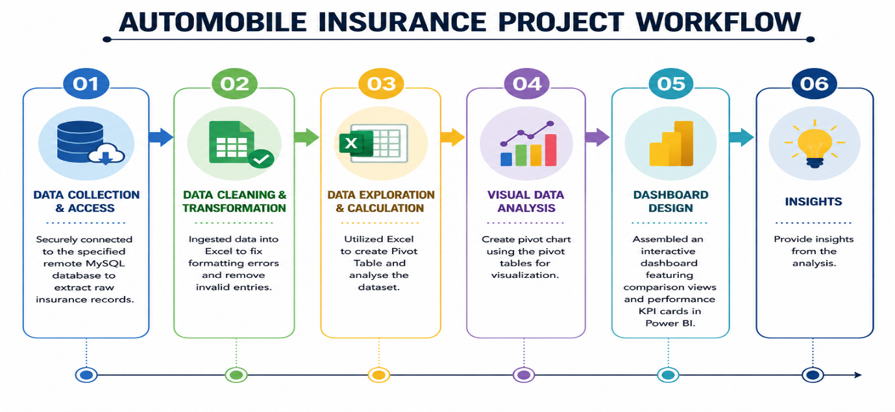
Fig 5.1
Chapter 6:
ANALYSIS
COMPLAINT DIAGNOSTIC REPORT
Analysis 1: Complaint Types
Pivot Table Used
Complaint Type | Total Complaints
Upheld Complaints | 4,216
Question of Fact Complaints | 11,474
Not Upheld Complaints | 20,229

Fig 6.1
Interpretation
The complaint analysis reveals that Not Upheld Complaints constitute the largest category, accounting for 20,229 complaints (56%) of all complaints received during the study period. These complaints were investigated but ultimately did not result in findings against the insurance companies.
Question of Fact Complaints account for 11,474 complaints (32%). These cases typically involve disputes where additional evidence or factual clarification is required before a final determination can be made.
Upheld Complaints represent the smallest category with 4,216 complaints (12%). These complaints were validated by regulators, indicating that the insurer was found responsible for service deficiencies, claim handling issues, policy disputes, or other customer service concerns.
The distribution suggests that while a large number of customers file complaints, only a relatively small proportion are ultimately upheld after investigation. This indicates that many complaints arise from misunderstandings, documentation issues, or disputes that cannot be substantiated through regulatory review.

Key Insights
- Not Upheld Complaints represent the majority (56%) of all complaints.
- Upheld Complaints account for only 12% of total complaints.
- Nearly 1 out of every 8 complaints results in regulatory action against an insurer.
- The large number of Question of Fact Complaints (32%) indicates that many cases involve complex claim disputes requiring further investigation.
- Insurance companies should focus on improving communication and documentation processes to reduce complaint volumes and improve customer satisfaction.

Analysis 2: Complaint Trends Over Time
Pivot Table Used
Filing Year | Upheld Complaints | Question of Fact Complaints | Not Upheld Complaints
2009 | 966 | 2,104 | 3,738
2010 | 621 | 2,395 | 3,410
2011 | 478 | 1,423 | 2,799
2012 | 459 | 1,190 | 2,374
2013 | 520 | 972 | 1,897
2014 | 610 | 1,382 | 2,495
2015 | 281 | 1,004 | 1,758
2016 | 281 | 1,004 | 1,758
Total | 4,216 | 11,474 | 20,229

Fig 6.2
Interpretation
The trend analysis shows that complaint volumes generally declined between 2009 and 2016 across all complaint categories. Not Upheld Complaints remained the most common type of complaint throughout the period, while Upheld Complaints consistently represented the smallest category.
Upheld Complaints decreased from 966 in 2009 to 281 in 2016, indicating a significant reduction in cases where insurers were found responsible for customer grievances. Similarly, Question of Fact Complaints declined from 2,104 to 1,004, while Not Upheld Complaints fell from 3,738 to 1,758 during the same period.
A temporary increase in complaint volumes can be observed in 2014, particularly for Question of Fact and Not Upheld Complaints. This may be attributed to increased claim activity, operational challenges, or changes in regulatory requirements. However, complaint levels resumed their downward trend after 2014.
Overall, the declining trend suggests improvements in claims handling processes, customer service quality, complaint resolution mechanisms, and regulatory compliance across the automobile insurance industry. The reduction in upheld complaints is especially important, as it indicates fewer instances where insurance companies were found at fault after regulatory investigation.

Key Findings
- Not Upheld Complaints remained the largest complaint category throughout the study period.
- Upheld Complaints decreased significantly from 966 in 2009 to 281 in 2016, representing a reduction of approximately 71%.
- Question of Fact Complaints declined from 2,104 to 1,004, indicating fewer disputed cases requiring further investigation.
- Not Upheld Complaints decreased from 3,738 to 1,758, suggesting an overall reduction in complaint volumes.
- A temporary increase in complaint levels is observed in 2014, particularly for Question of Fact and Not Upheld Complaints. This may indicate short-term operational challenges, regulatory changes, or increased claim activity during that period.
- After 2014, complaint volumes resumed their downward trend and reached their lowest levels by 2015–2016.

The overall downward trend in complaints indicates that automobile insurers improved their operational efficiency and customer service quality over the study period. The substantial reduction in upheld complaints is particularly significant, as it suggests fewer cases where insurers were found responsible for service deficiencies.

Analysis 3: Company Improvement Analysis
The objective of this analysis is to identify an insurance company that requires operational improvement based on customer complaint performance. Three key performance indicators were considered:
- Complaint Ratio
- Upheld Complaints
- Company Ranking

The Complaint Ratio indicates the number of upheld complaints relative to the company's premium volume. Upheld Complaints represent cases where the insurer was found responsible by regulators. Ranking reflects the company's overall position in the DFS complaint rankings.

Top Companies by Complaint Ratio
Company Name | Average Complaint Ratio
New Hampshire Insurance Company | 455.37
Clarendon National Insurance Company | 280.45
OneBeacon Insurance Company | 128.00
Greater New York Mutual Insurance Company | 74.54
Zurich American Insurance Company | 36.58
Infinity Casualty Insurance Company | 31.57
Victoria Fire & Casualty Company | 30.82
Long Island Insurance Company | 25.89
National Union Fire Insurance Company of Pittsburgh, Pa. | 20.48
Chartis Property Casualty Company | 18.54

Fig 6.3

Interpretation
New Hampshire Insurance Company has the highest complaint ratio, followed by Clarendon National Insurance Company and OneBeacon Insurance Company. A higher complaint ratio indicates more upheld complaints relative to the amount of business conducted.
However, complaint ratio alone is not sufficient because some companies may have very low premium volumes, causing ratios to appear unusually high.

Top Companies by Upheld Complaints
Company Name | Total Upheld Complaints
Allstate Insurance Company | 760
Country-Wide Insurance Company | 368
State Farm Mutual Automobile Insurance Company | 326
Long Island Insurance Company | 265
Allstate Property and Casualty Insurance Company | 172
GEICO General Insurance Company | 171
Liberty Mutual Fire Insurance Company | 132
GEICO Indemnity Company | 70
Travelers Home and Marine Insurance Company | 62
Government Employees Insurance Company | 60

Fig 6.4
Interpretation
Allstate Insurance Company recorded the largest number of upheld complaints. However, large insurers often have significantly larger customer bases and premium volumes, which naturally lead to higher complaint counts.
Therefore, upheld complaints should be evaluated together with complaint ratio and ranking.
Companies with the Poorest Rankings  Company Name | Average Ranking
Zurich American Insurance Company |  | 180
Long Island Insurance Company |  | 179
Clarendon National Insurance Company |  | 179
OneBeacon Insurance Company |  | 178
Granite State Insurance Company |  | 178
ACE American Insurance Company |  | 177
Greater New York Mutual Insurance Company |  | 177
Chartis Property Casualty Company |  | 175
Infinity Casualty Insurance Company |  | 175
National Continental Insurance Company |  | 174
Hudson Insurance Company |  | 174
Fig 6.5
Interpretation
These companies occupy the lowest positions in the DFS ranking system, indicating relatively poor complaint performance compared to competitors.
A poor ranking suggests that the company receives more validated complaints relative to its business volume.

Selected Company for Improvement:
Long Island Insurance Company
After evaluating all three metrics, Long Island Insurance Company was selected as the company requiring improvement.

Performance Summary
Metric | Value
Complaint Ratio | 25.886
Upheld Complaints | 265
Total Complaints | 355
Average Ranking | 179

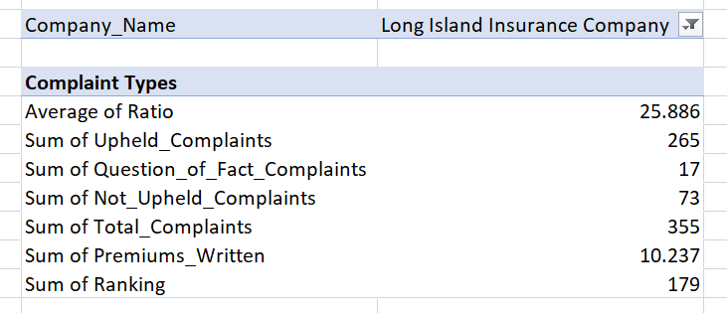
Fig 6.6

Why Long Island Insurance Company Was Selected
Although New Hampshire Insurance Company and Clarendon National Insurance Company have higher complaint ratios, they have significantly fewer upheld complaints.
Long Island Insurance Company stands out because it performs poorly across multiple indicators simultaneously:
- High Complaint Ratio (25.886)
- Very High Upheld Complaints (265)
- High Total Complaints (355)
- Poor Ranking (179)
This combination indicates that the company experiences a substantial number of validated customer complaints while also being ranked among the lowest-performing insurers in the dataset.
Unlike some companies that exhibit only one negative indicator, Long Island Insurance Company demonstrates poor performance across all major complaint-related measures.

Based on complaint ratio analysis, upheld complaint volume, and DFS ranking performance, Long Island Insurance Company is the most suitable candidate for improvement. Its high complaint burden and poor ranking indicate significant opportunities for enhancing customer service quality, claims management efficiency, and overall operational performance.

Progress of Premiums over a few years’ period and any causes:

Analysis 4: Premium Trend Analysis
Premiums Written by Year
Year | Premiums Written
2009 | 9,712.95
2010 | 10,027.53
2011 | 10,283.60
2012 | 10,609.53
2013 | 10,949.20
2014 | 11,290.65
2015 | 12,276.91
2016 | 12,276.91

Fig 6.7
Interpretation
The chart demonstrates a strong and consistent upward trend in automobile insurance premiums from 2009 to 2016. The steady increase suggests continued growth in the automobile insurance market and reflects increasing business activity among insurers.
Several factors may have contributed to this trend:
- Growth in the number of insured vehicles.
- Increased consumer awareness regarding insurance coverage.
- Expansion of insurance products and policy offerings.
- Periodic premium rate revisions by insurance companies.
- Rising repair costs, healthcare expenses, and inflation.
- Improved customer retention and policy renewals.
The significant increase observed between 2014 and 2015 may indicate stronger market demand, premium pricing adjustments, or increased vehicle ownership during that period.
Overall, the premium trend reflects healthy growth in the automobile insurance sector and demonstrates the industry's ability to expand premium income over time.

Key Findings
- Premium volumes increased consistently throughout the study period.
- Total premiums rose from $9,712.95 million in 2009 to $12,276.91 million in 2016.
- This represents an overall increase of approximately 26.4% over the eight-year period.
- The largest increase occurred between 2014 and 2015, when premiums increased by nearly 986 million dollars.
- Premium growth remained positive throughout the period, with no major decline observed.
- Premium values stabilized in 2016, indicating a period of market maturity and steady business performance.

Analysis 5: Potential Causes Behind Fluctuations in Premiums
The chart compares Total Premiums Written and Total Complaints across filing years from 2009 to 2016.
Pivot Table Used
Filing Year | Premiums Written | Total Complaints
2009 | 9,712.95 | 6,808
2010 | 10,027.53 | 6,426
2011 | 10,283.60 | 4,700
2012 | 10,609.53 | 4,023
2013 | 10,949.20 | 3,389
2014 | 11,290.65 | 4,487
2015 | 12,276.91 | 3,043
2016 | 12,276.91 | 3,043
Fig 6.8

Interpretation
The inverse relationship between premiums and complaints suggests that insurers were able to increase premium collections while reducing complaint levels.
This trend may indicate:
- Improved Claims Management
  - Insurance companies may have improved claim settlement processes and customer service practices.
  - Better handling of claims can reduce customer dissatisfaction and complaint volumes.
- Market Expansion
  - Growth in the number of insured vehicles and policyholders may have contributed to higher premium collections.
  - Increased market penetration often leads to higher total premiums written.

- Economic and Cost Factors
  - Rising vehicle repair costs, medical expenses, and inflation can lead insurers to adjust premium rates upward.
  - These factors may explain the continuous increase in premiums.
- Regulatory and Risk-Based Pricing
  - Insurance companies periodically revise premiums to reflect changing risk profiles and regulatory requirements.
  - Such adjustments may contribute to premium growth even when complaint levels decline.
Key Findings
- Total Premiums Written increased steadily from approximately 9,700 million dollars in 2009 to over 12,200 million dollars in 2016.
- Total Complaints decreased significantly from approximately 6,800 complaints in 2009 to around 3,000 complaints in 2016.
- A temporary increase in complaints can be observed in 2014, after which complaints resumed their downward trend.
- Premium growth remained positive throughout the period despite fluctuations in complaint volumes.
Potential Causes Behind Premium Fluctuations
- Changes in claim frequency and claim costs.
- Regulatory adjustments affecting insurance pricing.
- Economic growth and increased vehicle ownership.
- Market competition among insurance companies.
- Improvements in customer satisfaction and claims handling.

Analysis 6: Historical Premium Trend
Pivot Table Used
Year | Premiums Written
2009 | 9,712.95
2010 | 10,027.53
2011 | 10,283.60
2012 | 10,609.53
2013 | 10,949.20
2014 | 11,290.65
2015 | 12,276.91
2016 | 12,276.91

Fig 6.9

Interpretation
The historical premium trend chart shows a clear upward movement in premiums written between 2009 and 2016. The trendline indicates stable long-term growth with no major declines during the study period. Although premium growth slowed slightly in 2016, the overall direction remains positive. This pattern suggests a healthy and expanding automobile insurance market supported by increasing policy demand, premium adjustments, and improved insurer performance.

Future Premium Trend Forecast
Based on the historical data and the upward linear trend:
- Premiums are expected to continue increasing in future years.
- Growth is likely to remain moderate and stable if current market conditions persist.
- Insurance companies may continue expanding premium volumes through:
  - Improved customer retention
  - Better claims management
  - New policy offerings
  - Growth in automobile insurance demand
The analysis of premiums written between 2009 and 2016 shows a strong and consistent upward trend. The linear trendline suggests that premium volumes are likely to continue growing in future years. Factors such as declining complaint levels, favourable market conditions, increasing vehicle ownership, and effective insurance operations are expected to support continued growth in premium income.

Chapter 7:
Dashboard
Comparison Report of 5 Insurance Companies
To compare the performance of automobile insurance companies, an interactive Power BI dashboard was developed. The dashboard compares five selected insurance companies based on key complaint and business performance indicators.
The selected companies are:
- Allstate Insurance Company
- GEICO General Insurance Company
- Liberty Mutual Fire Insurance Company
- Progressive Casualty Insurance Company
- State Farm Mutual Automobile Insurance Company
The dashboard enables users to evaluate complaint levels, complaint ratios, rankings, premiums written, and complaint type distributions through interactive visualizations and filters.

Dashboard Components
KPI Cards
The dashboard contains five Key Performance Indicators (KPIs):
KPI | Description
Total Complaints | Total number of complaints received by the selected companies
Average Ratio | Average complaint ratio of the selected companies
Average Ranking | Average DFS ranking
Total Premiums Written | Total premiums written by the selected companies
Total Upheld Complaints | Number of complaints upheld by DFS
These KPIs provide a quick summary of overall company performance.

Upheld Complaints by Company
This clustered bar chart compares the number of upheld complaints across the five companies.
Observation:
- Allstate Insurance Company recorded the highest number of upheld complaints.
- Progressive Casualty Insurance Company recorded the lowest number of upheld complaints.
- Higher upheld complaints indicate greater numbers of customer grievances that were validated by regulators.

Premiums Written by Company
This bar chart compares the total premiums written by each company.
Observation:
- GEICO General Insurance Company generated the highest premium volume.
- State Farm Mutual Automobile Insurance Company ranked second in premium generation.
- Higher premiums indicate larger market presence and customer base.

Average Ratio by Company
This chart compares the complaint ratio of the selected companies.
Observation:
- Allstate Insurance Company has the highest complaint ratio among the selected companies.
- GEICO General Insurance Company has the lowest complaint ratio.
- A lower complaint ratio indicates better complaint management relative to business volume.

Average Ranking by Company
This chart compares the DFS ranking of each company.
Observation:
- Allstate Insurance Company has the highest average ranking value among the selected companies.
- GEICO General Insurance Company has the lowest ranking value.
- Lower ranking values generally indicate better overall complaint performance.

Complaint Type Distribution by Company
A stacked column chart was created to compare:
- Upheld Complaints
- Question of Fact Complaints
- Not Upheld Complaints
for each company.

Observation:
- Not Upheld Complaints constitute the largest share of complaints for all companies.
- Upheld Complaints represent a smaller proportion of total complaints.
- Allstate Insurance Company recorded the highest overall complaint volume among the selected companies.
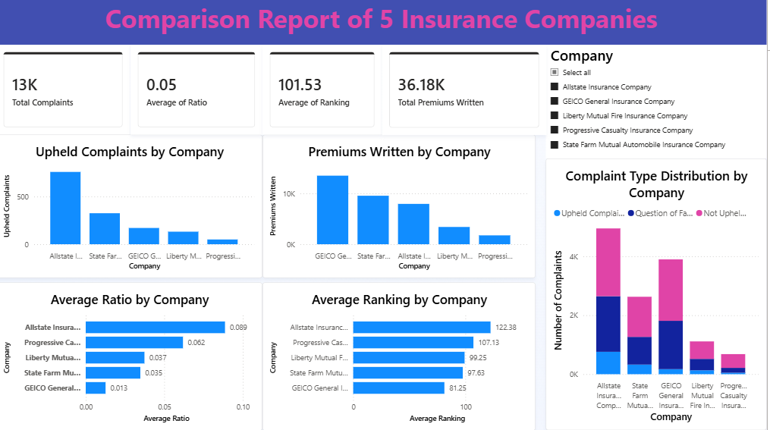
Fig 7.1
Key Insights from Dashboard
Insight 1: Market Leaders
GEICO General Insurance Company and State Farm Mutual Automobile Insurance Company generated the highest premiums, indicating strong market positions.
Insight 2: Complaint Management
GEICO General Insurance Company maintains a relatively low complaint ratio despite handling a large premium volume, suggesting effective complaint management.
Insight 3: High Complaint Burden
Allstate Insurance Company recorded the highest number of upheld complaints and complaint ratio among the selected companies, indicating areas requiring improvement.
Insight 4: Complaint Composition
Across all companies, Not Upheld Complaints represent the majority of complaints, suggesting that many customer complaints could not be substantiated after investigation.

The Power BI dashboard successfully compares five automobile insurance companies using complaint statistics, premium volumes, complaint ratios, and rankings. The analysis reveals significant differences in customer complaint levels and business performance. GEICO and State Farm demonstrate strong premium performance with relatively better complaint ratios, while Allstate shows higher complaint levels and may benefit from improved claims handling and customer service processes.

Chapter 8:
INSIGHTS
INSIGHTS
Insight 1: Complaint Volumes Have Declined
The overall number of complaints decreased significantly between 2009 and 2016, indicating industry-wide improvements in customer service and claims management.
Insight 2: Upheld Complaints Represent a Small Share
Although complaint volumes are high, only a relatively small proportion are upheld, suggesting that many complaints are resolved in favour of insurers.
Insight 3: Premiums Continue to Increase
Premium volumes demonstrate a steady upward trend throughout the study period, indicating market growth and increased insurance adoption.
Insight 4: Complaint Ratios Differ Significantly
Some insurers maintain extremely low complaint ratios while others exhibit substantially higher ratios, indicating major differences in service quality.
Insight 5: Long Island Insurance Company Requires Attention
The combination of high complaint ratios, large numbers of upheld complaints, and poor ranking identifies Long Island Insurance Company as a strong candidate for operational improvement.
Insight 6: Premium Growth Does Not Necessarily Increase Complaints
Although premiums increased by approximately 26% between 2009 and 2016, complaint volumes decreased by more than 55%.
This suggests that insurers improved operational efficiency while expanding their business.
Chapter 9:
CONCLUSION
This project successfully analysed automobile insurance complaint data using Microsoft Excel and Power BI. The analysis identified complaint trends, premium growth patterns, and company performance differences. Complaint volumes declined over time, while premium volumes steadily increased.
Long Island Insurance Company was identified as the most suitable candidate for improvement due to its high complaint ratio, large number of upheld complaints, and poor ranking. The Power BI dashboard provided a comprehensive comparison of selected insurance companies and demonstrated the value of Business Intelligence tools in evaluating insurer performance.
The findings can assist insurance companies in improving customer service, complaint management, and operational efficiency while supporting data-driven decision-making.

